**FIND IF THE TRIPLET CONTAINS ZERO SUM**

#include<iostream.h>

#include<conio.h>

void Triplet(int arr[],int n)

{

int answer = 0; //0 refers to false and 1 refers to True

for(int i=0;i<n-2;i++)

{

for(int j=i+1;j<n-1;j++)

{

for(int k=j+1;k<n;k++)

{

if(arr[i]+arr[j]+arr[k]==0)

answer=1;

}

}

}

if(answer==1)

{

cout<<"Yes,triplet with zero sum exists";

}

else

{

cout<<"No triplet with zero sum exists";//"\n\n"<<answer<<endl;

}

}

void main()

{

clrscr();

cout<<"FIND IF THE TRIPLET CONTAINS ZERO SUM"<<endl;

int size;

cout<<"\nEnter the size of the array:";

cin>>size;

cout<<"\nEnter the values:"<<endl;

int *arr= new int(size);

for(int i=0;i<size;i++)

cin>>arr[i];

Triplet(arr,size);

getch();

}

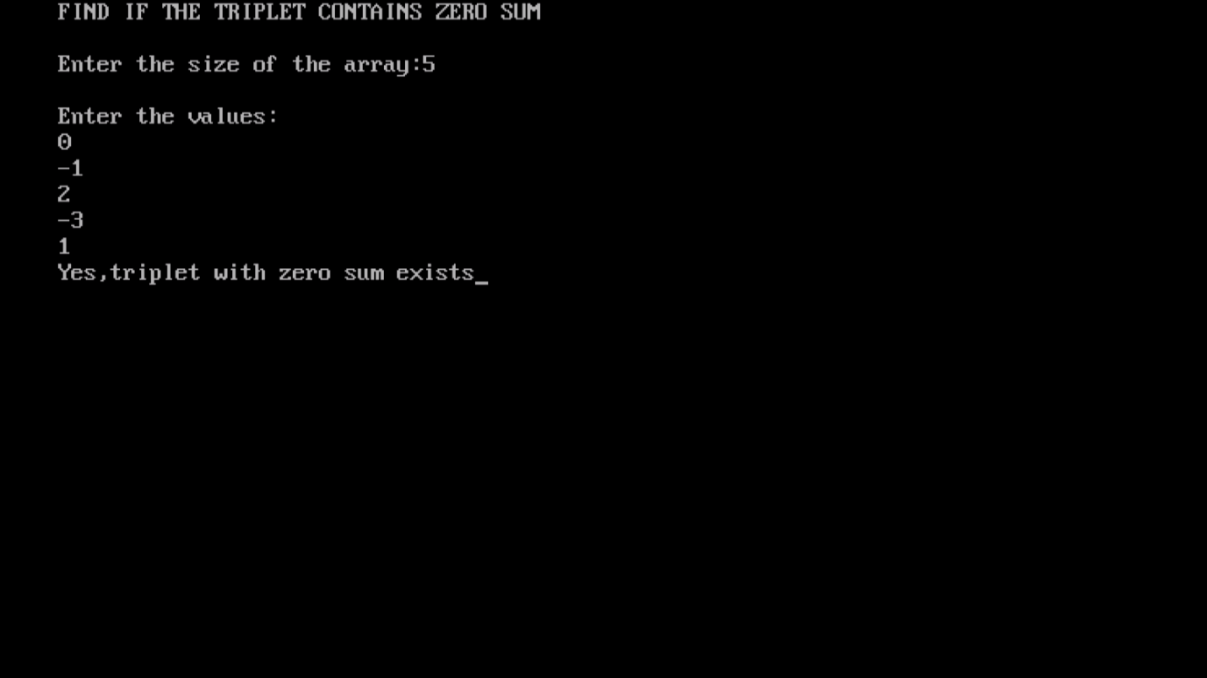

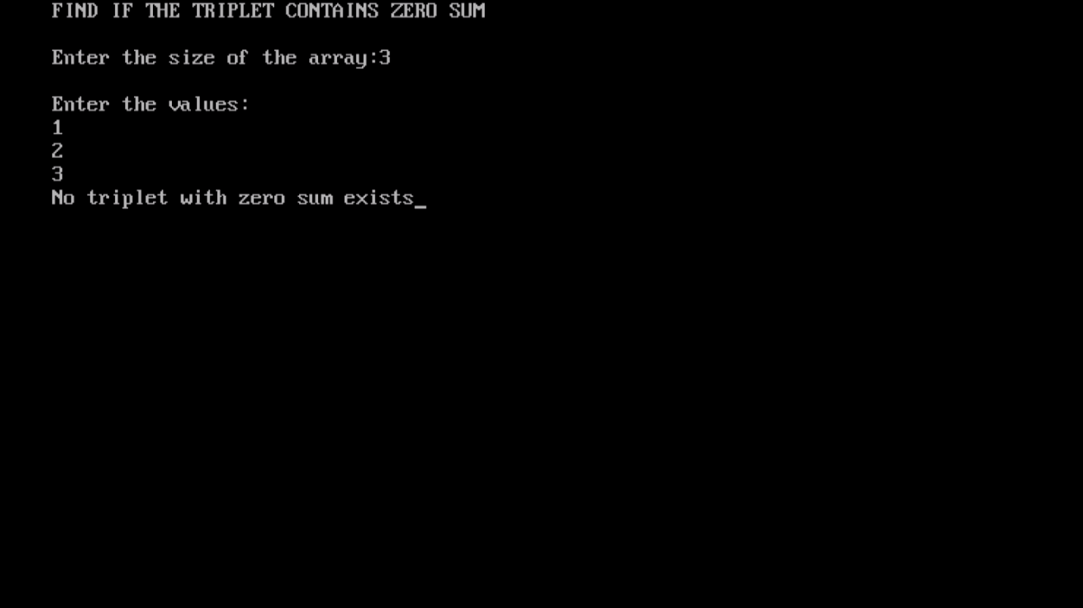

**//This code was contributed by Vijeyandrian & Sundar, MCA Section ’B’**